**Peshawar:**

Bab-e-Khyber

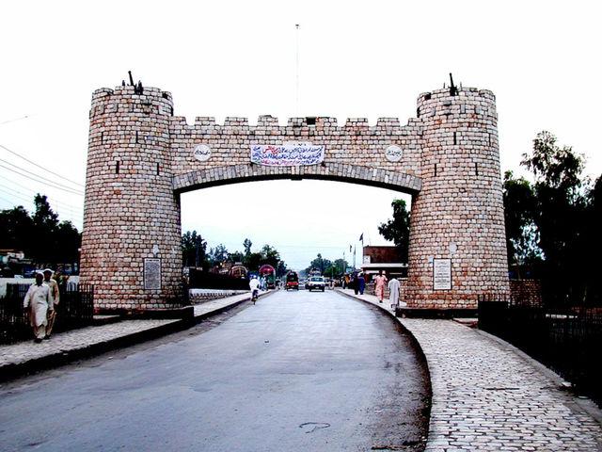

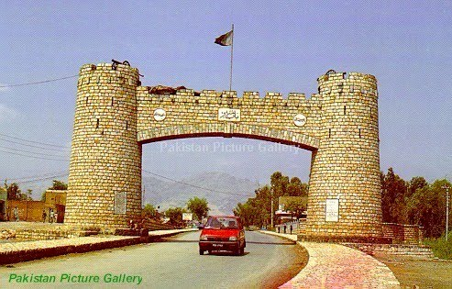

**Bab-e-Khyber** **"Khyber Gate"**) is a monument which stands at the entrance of the Khyber Pass in the Federally Administered Tribal Areas of Pakistan. The gate is immediately west of Peshawar, while the historic Jamrud Fort is adjacent to the gate. The gate was built in 1964 by the military government of Ayub Khan. Khyber Gate is considered to be the most famous post-independence structure in Khyber Agency.